1. Write a program in java to accept a string and change the case of each letter of the string.

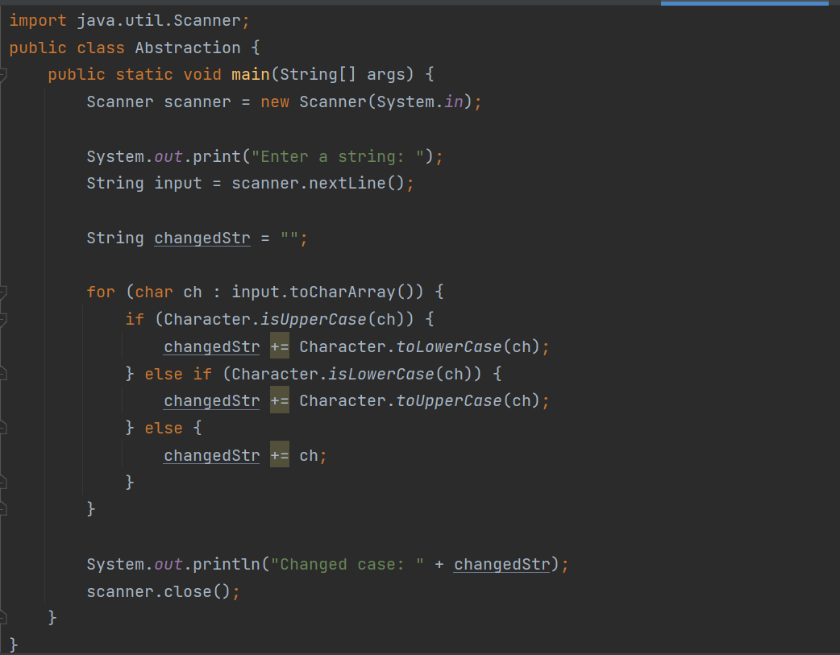

1. Write a program in java to accept a string and display it after reversing.’

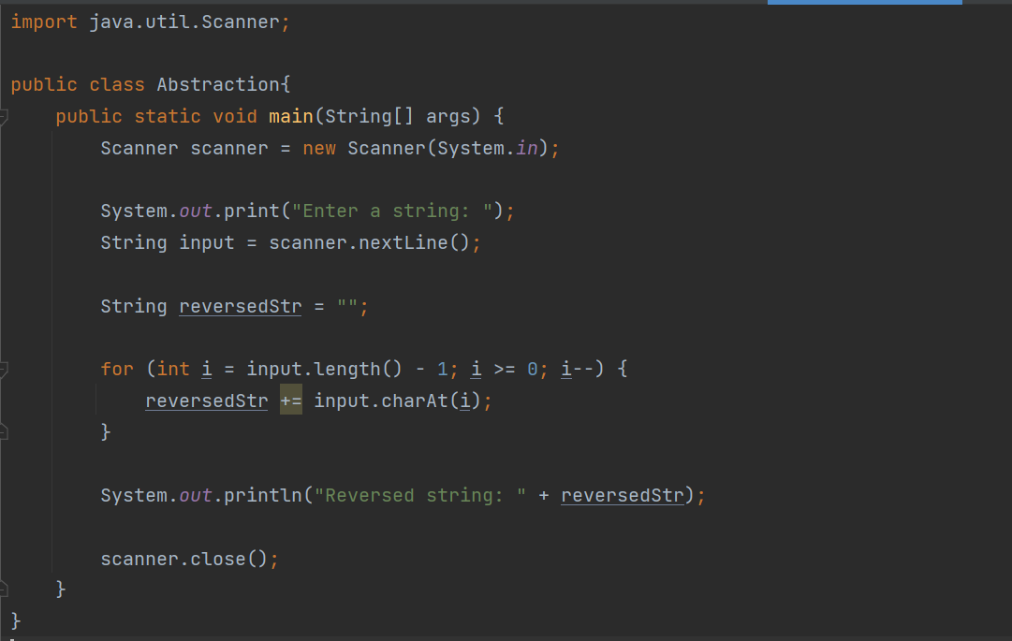

1. Write a program in java to accept a word and check whether the word is palindrome or not.

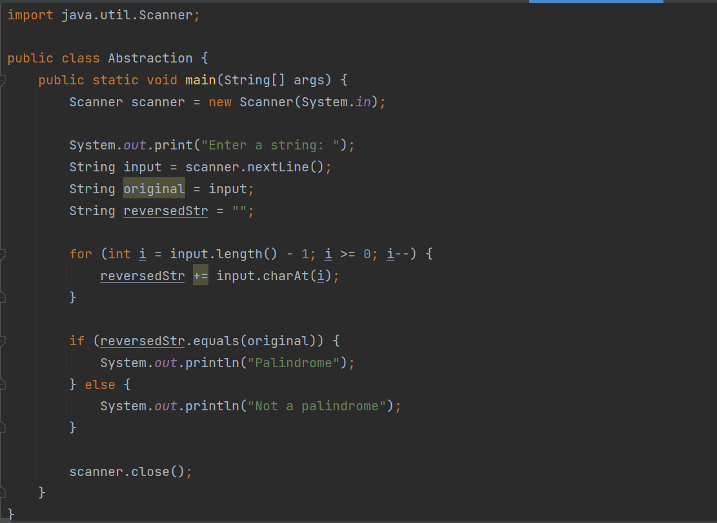

4) Write a program in java to accept a word and display the ascii code of each character of the word.

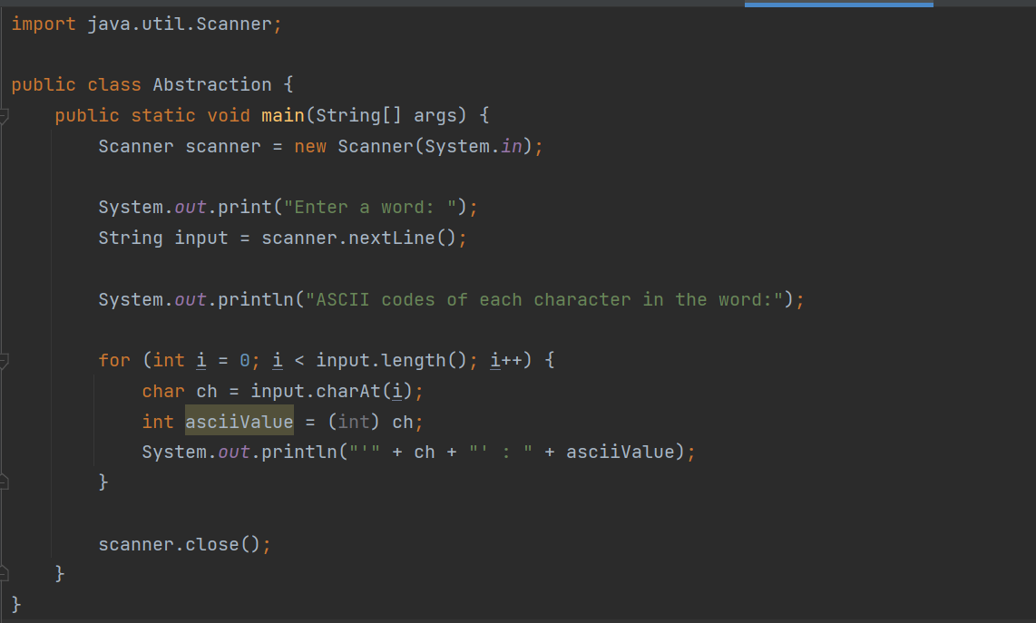

1. Write a program in java to find out the length of a given string.

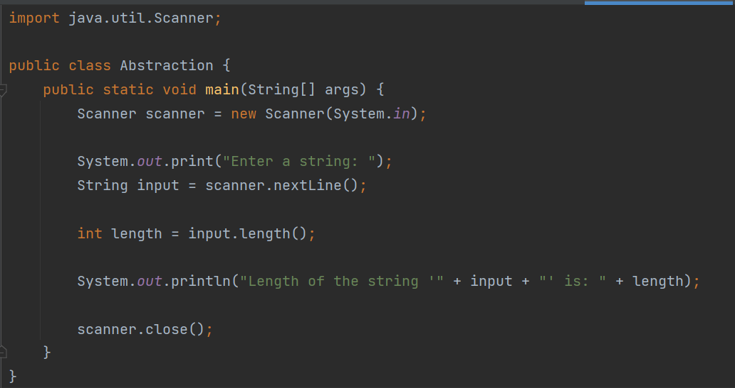

6) Create a function which accepts an integer as parameter and return true if it is a

palindrome number or not. In the main() method input 10 integers and print the largest

palindrome number if any.

// 10 numbers from usser

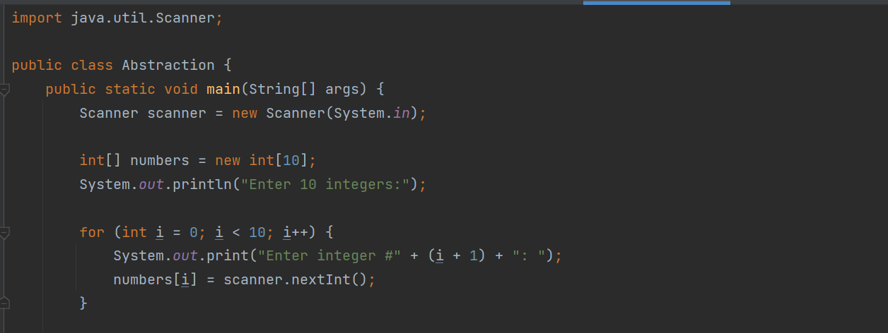

//Print the result

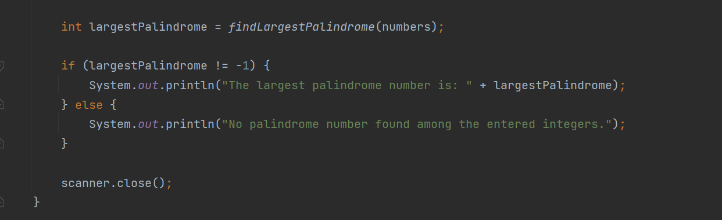

//Function to check if palindrome or not

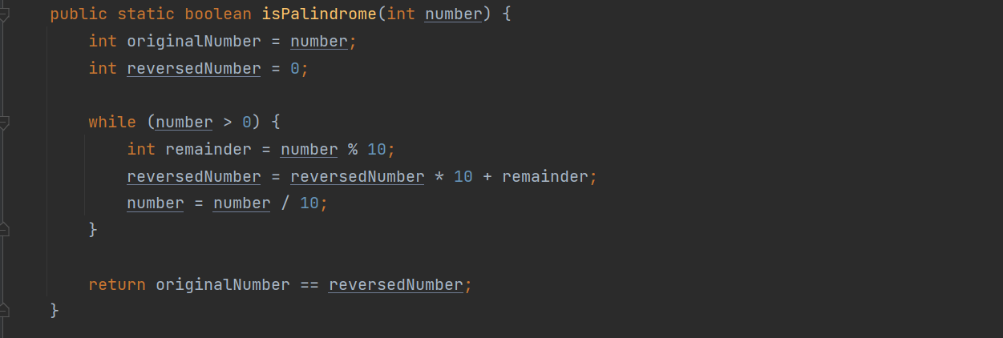

// Function to find the largest palindrome number in an array of integers

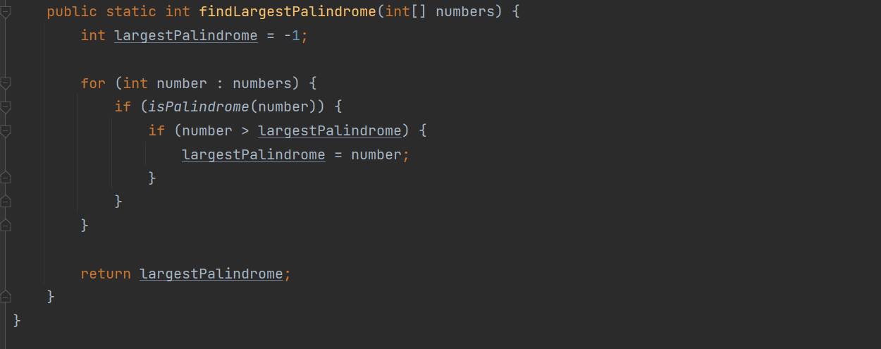

1. Create a class called generateprime which will be used to generate n number of primenumbers.

The class should have the following methods:

(i) Method called isprime() which accepts an integer as a parameter and return true if it is a

Prime number otherwise return false.

(ii) Method called display() which accepts an integer n as scanner input and display the first n prime number by calling the above function.

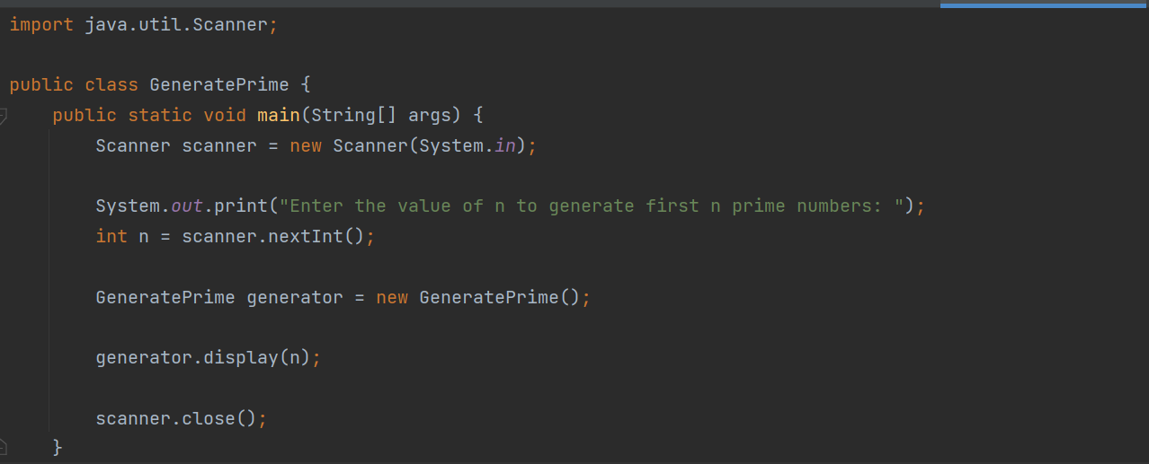

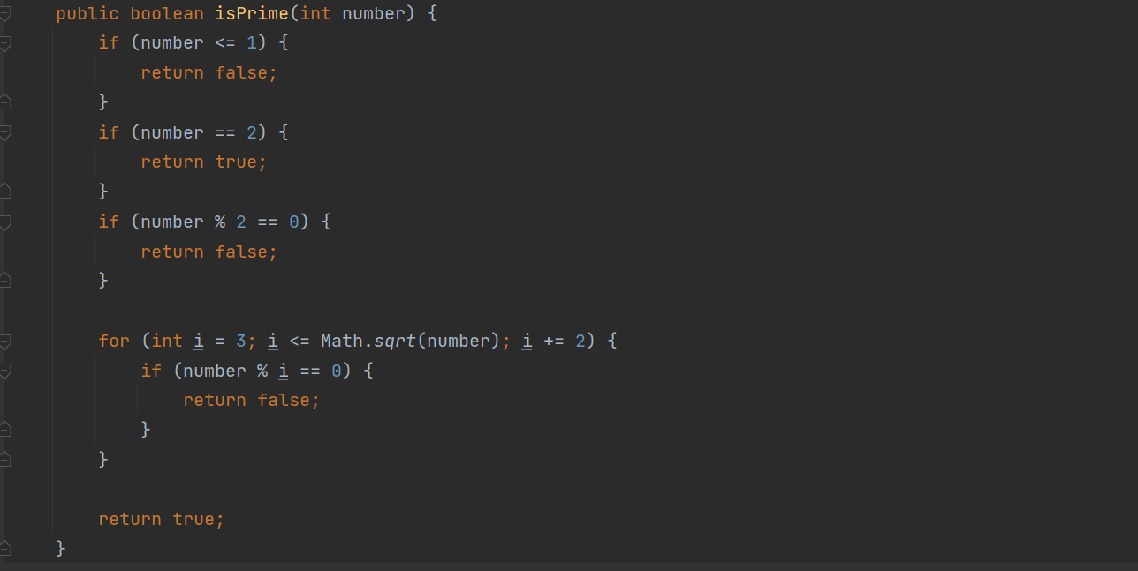

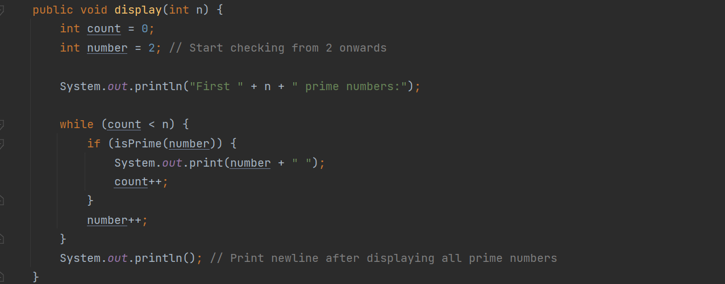

8) Using overloading technique, write methods to:

• Accept two int type data as parameters and return their sum.

• Accept three int type data as parameters and return their sum.

• Accept two double type data as parameter and return their sum.

• Accept a double type and int type as parameter and return their sum.

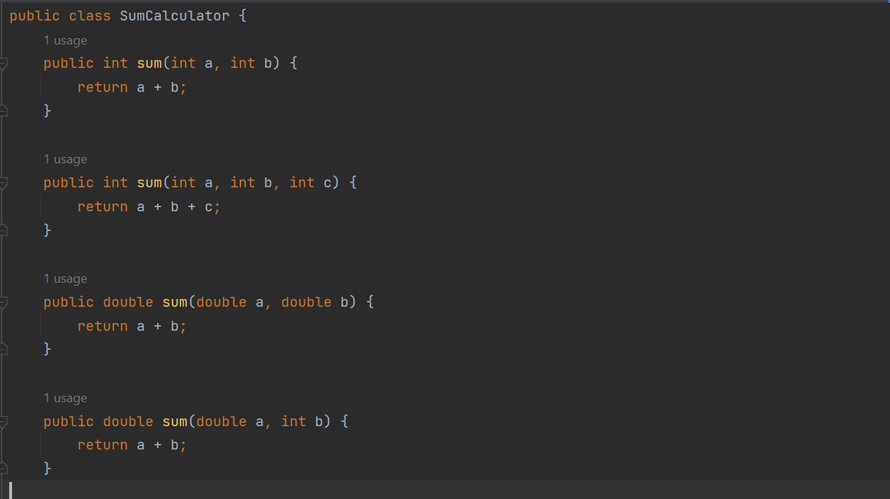

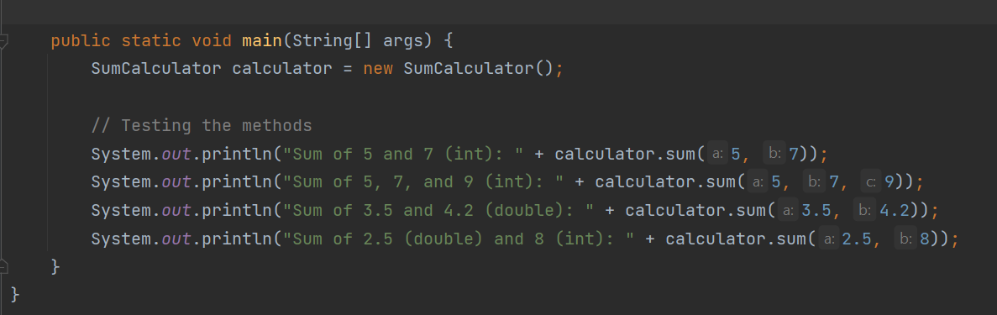

9) Create a function which accepts an integer as parameter and return true if it is a prime number Otherwise return false. Create another function which accepts an integer as parameter and Return true if it is palindrome otherwise return false. In the main() method display all three Digit pal-prime number. Palprime numbers are such numbers which are both palindrome as Well as prime numbers.

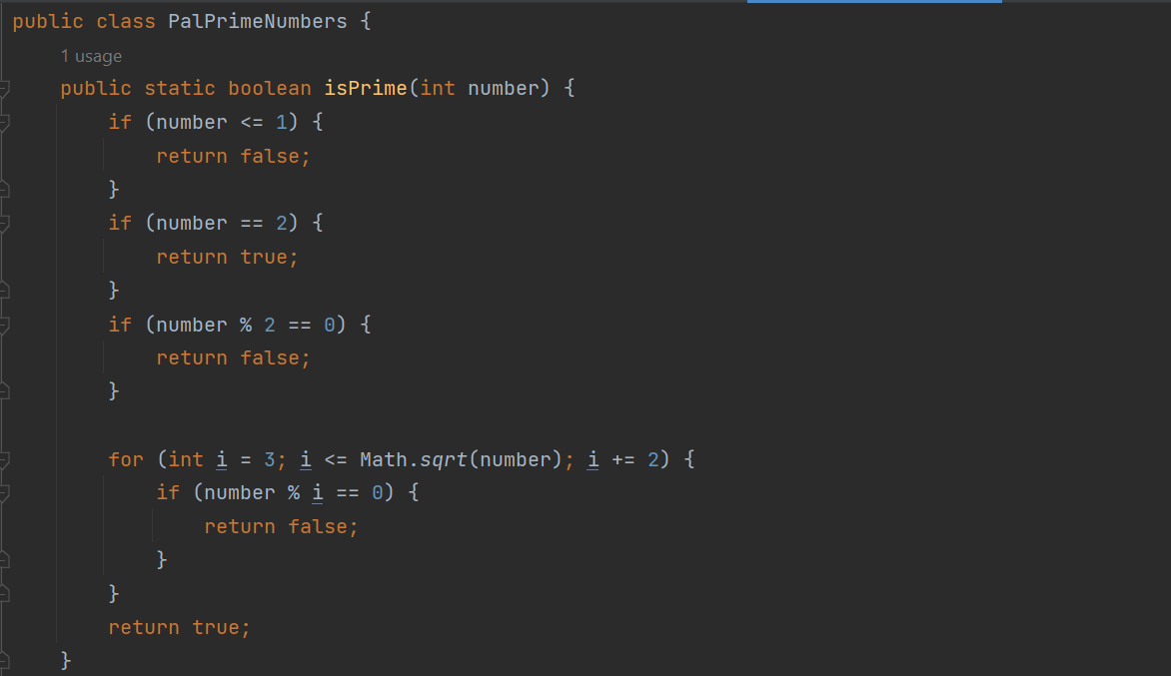

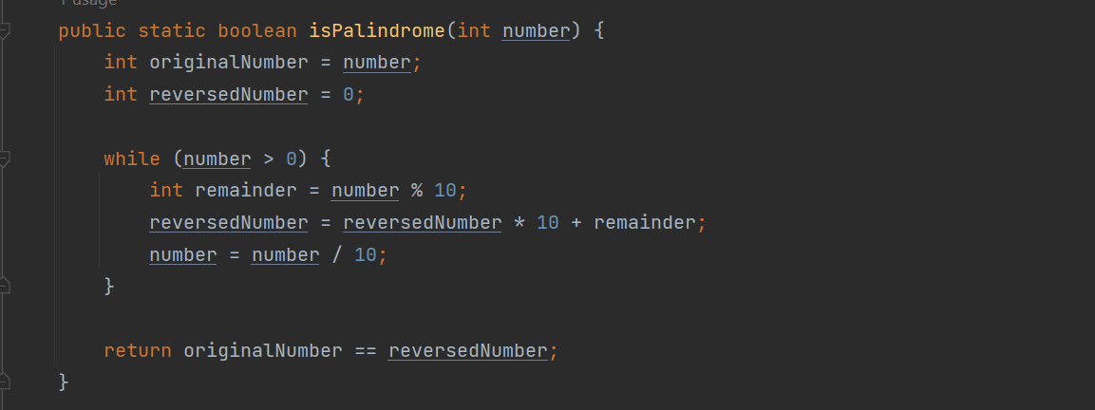

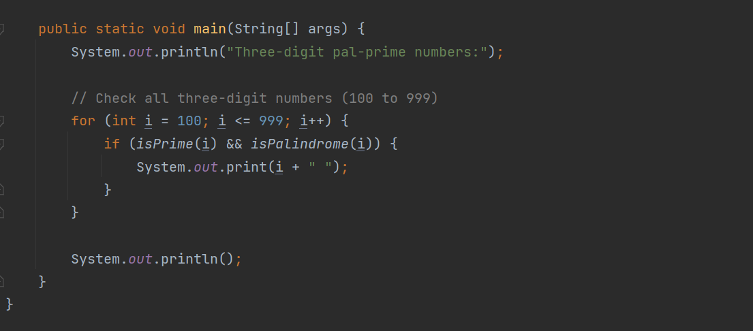

10) Create a function which accepts an integer as parameter and return the sum of its digits.

Create another function which accepts an integer as parameter and return true if it is

magic number otherwise return false. In the main input an integer and check whether it is a

magic number or not. If you iterate the process of summing the decimal digits of a number and if this process terminates in 1, then the original number is called a magic number.

